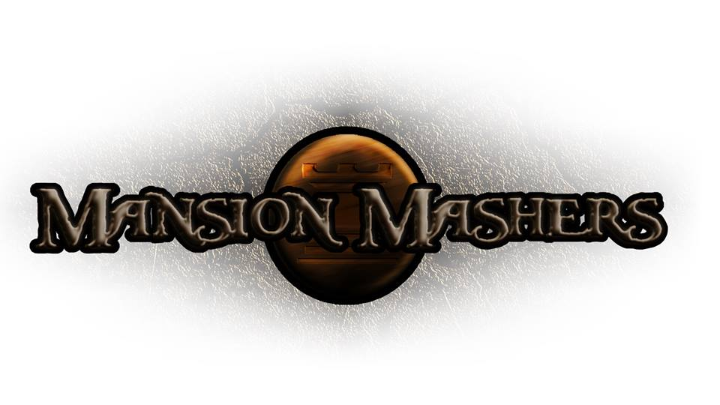**Weekly Production Report**

**Week 8**

**February 27, 2014**

**By Juli Gregg**

**High Concept**:

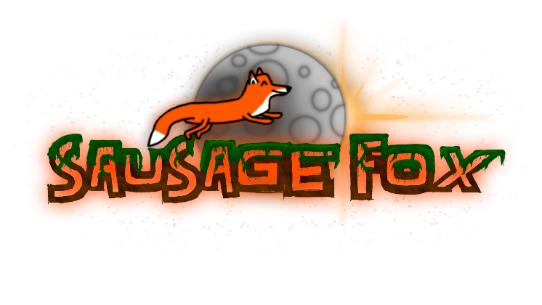A 2-D fast-paced, side scrolling hack and slash game set in a cartoon fantasy world with character ability progression.

**Producer:**

Juli Gregg

**Tech Director**:

Dan Muller

**Game Designer**:

Luke Conlon

**Product Manager**:

Kaden Nugent

Project Status:

Green

Current Milestone:

Alpha

Accomplishments:

|  |  |
| --- | --- |
| **Juli Gregg:** | Fixed art for Level 1. Placed platforms and walls for Level 1. Created moving bounding boxes. Implemented basic editing tools. Implemented camera panning for level progression. Created more level art. |
| **Dan Muller:** | Implemented moving backgrounds feature for Main Menu. Created logic for level map progression. Fixed bugs with HUD. Created a wall object. Added another collision type. Fixed player input and enemy spawning lag. Implemented an enemy spawner. Enabled cheat system. Implemented buff objects and functionalities. |
| **Luke Conlon:** | Polished all art and animations for the Main Menu. Implemented basic enemy type logic. Optimized enemy object creation/spawning. |
| **Kaden Nugent:** | Implemented basics for Weapon Shop. Fixed and cleaned all memory leaks. Fixed weapon fall when dropped. Merged Sound Manager into Object Manager. |

Objectives:

|  |  |
| --- | --- |
| **Juli Gregg:** | Work to finish more level art and continue to place platforms and wall objects about the levels. Update camera panning to account for buffs increasing the players speed. |
| **Dan Muller:** | Continue to fix and track down bugs. Aid in boss logic development. Implement functions as needed for level functionality. |
| **Luke Conlon:** | Continue to work on level art and design. Create more AI logic for enemies and bosses. Create art for tougher enemies and bosses. |
| **Kaden Nugent:** | Start developing levels and logic for bosses. Setup logic for the item shop. |

Group Accomplishments:

|  |  |
| --- | --- |
| **Weekly Group Meeting** | Together we went through and planned out what we needed to accomplish this week in order to get Level 1 up and running so it could be playable for Tartaglia on Friday. |
| **Repository**  **Commit Stats** | This week: 165 commits  In a month: 466 commits |

Group Objectives:

|  |  |
| --- | --- |
| **Weekly Group Meeting** | Plan to discuss map design for moving between levels. Also discuss implementation for boss AI. Get sound assets from our Sound Designer. |

Highlights:

Everyone is excited by the look of our Main Menu and how polished it feels. This gave the group energy to want to make the game live up to the look of the Main Menu.

Risks & Mitigations:

|  |  |
| --- | --- |
| **RISKS:** | (1) We have a lot of plans for this game that due to limited amount of time we may not be able to implement everything that we want to.  (2) Dan’s laptop was fried by his power cord.  (3) We are having trouble finding areas to work together within DigiPen with reliable internet. |
| **MITIGATIONS:** | (1) Attempt to keep a realistic timeline and slowly weave in stretch goals as we achieve the basic requirements to make our game functional and fun.  (Ex. Multiplayer)  (2) We found someone who was able to let us borrow their secondary laptop for a few weeks while Dan’s gets fixed.  (3) We have addressed our concerns to Mark Ward in student affairs who also plays a role in Student Senate. |

**Signatures**

_____________________

Juli Gregg

_____________________

Dan Muller

_____________________

Luke Conlon

_____________________

Kaden Nugent